Sanyukta Adap

HI 2454 Data Science in Health Informatics

Date: 04/19/2023

**Analytical and Machine Learning Approaches to Classify Breast Cancer**

**Introduction:**

The likelihood of survival is extremely high when cancer is detected and treated in the earlier stages. It is well known that benign breast tumors put women at a higher risk of developing breast cancer. Over 1 million women in the USA are diagnosed with benign breast cancer each year, which is 4 times more prevalent than malignant breast cancer (Figueroa, 2021). BC cells become more invasive as they become more flexible. The extent of flexibility is reflected via deformations on the cells and their nuclei. These deformations change the morphology of the cell which thus can be used to determine the degree of malignancy of BC cells. (Antmen, 2019).

Thus, in this study, we aim to classify breast mass as Benign or Malignant on the basis of the morphology of the cell nuclei.

**Problem and Data:**

In this study, we used the [Breast Cancer Wisconsin](https://www.kaggle.com/datasets/uciml/breast-cancer-wisconsin-data) dataset retrieved from the Kaggle repository. We tried to use characteristics of the breast cell nucleus such as radius, perimeter, area, texture, etc, based on digitized images of breast mass fluid samples obtained after a fine needle aspiration (FNA) from subjects with dense breast masses. An FNA is a procedure in which a doctor draws a small sample of breast fluid or breast tissue from a suspicious location using a thin, hollow needle affixed to a syringe. If a breast area is suspected after an FNA, the sample is examined to look for cancer cells.

This dataset uses the morphological features of the nuclei of these cells as attributes to predict the presence of malignant or benign breast cancer. It had 33 columns that comprise of the ID, Diagnosis (M = malignant, B = benign) and Nuclear features. The Mean, standard error (se), and worst (mean of the three largest values) of each feature were calculated for every image, resulting in 30 features. The 33rd column is an Unnamed column. (Fig. 1)

**Fig. 1. List of all columns**

**Methodology:**

1. Data Analysis: The data was first split into train and test sets, and all analytics was performed on only the training set, leaving the test set untouched. The ‘id’ and ‘Unnamed: 32’ columns were non-value adding so we eliminated them from the dataset. Then, we used pandas profiling to perform some basic descriptive and quantile statistics on all the features. The Pandas Profile report indicated that there were no null/missing values in the data. So, the only step for cleaning was to convert categorical values present in the diagnosis into numeric values. We converted benign to 0 and malignant to 1.

Then the whole dataset was then normalized using the MinMaxNormalization function. Once this was done, we performed a set of exploratory data analyses to view various relationships between features of the dataset. Lastly, we performed Principle Component Analysis (PCA) on all the features to obtain new features.

1. Machine Learning: We trained ML models with both, the original features, and the new features obtained from PCA. We used ML classifier models such as Logistic Regression (LR), Decision Tree (DT), Random Forest (RF), Support Vector Machine (SVM), and K-nearest Neighbors (KNN) and compared their performances. The individual model performances were then evaluated by calculating the accuracy, precision, and recall scores.

For sensitive classifications, such as B and M in this case, we cannot afford to classify Malignant as Benign, or basically a false negative. Thus, in such a situation, the recall score is the most important as it takes into consideration the false negatives.

**Results and Conclusions:**

1. Statistics: With pandas profiling, we could determine the number of variables, no of observations, missing values, etc., about the dataset as a whole (Fig.2). Additionally, it also shows descriptive and quantile statistics of each attribute in the dataset. This consists of missing values, range, minimum, mean, maximum, standard deviation, interquartile range, etc for each attribute.

One example of the output in the report is shown in Fig. 3 and Fig. 4. The report for area_mean indicates that the values range from approx. 143 to 2501 with a mean of 663 (Fig. 3). The graph shown in Fig. 4 is a histogram of the values in the area_mean attribute. Looking at the image, we can say that the graph is skewed to the left, but the profile report gives the exact value of skewness.

**Fig. 2. Pandas Profile Report consisting of Dataset Statistics**

**Fig. 3. Pandas Profile Report consisting of Quantile and Descriptive Statistics for area_mean**

**Fig. 4. Pandas Profile Report consisting of Histogram for area_mean**

1. Exploratory Data Analysis: We plotted a Heatmap (Fig. 5) with normalized values of training data to determine the direct correlation between the variables. If we look closely at the darker shades of blue in the heatmap, we can observe that features related to radius, perimeter, and area are highly correlated with each other. Seems like a logical conclusion to draw since the larger the radius, the larger the perimeter, and the larger the area!

The scatter plots shown in Fig. 6 are plotted based on the top 3 prevalent features that had the strongest correlations with the label, i.e., the diagnosis (shown with red boxes). Though the plots seem to be able to distinguish between the two labels, there isn't a clear line of distinction between them. There still exists a significant overlap between the green and red 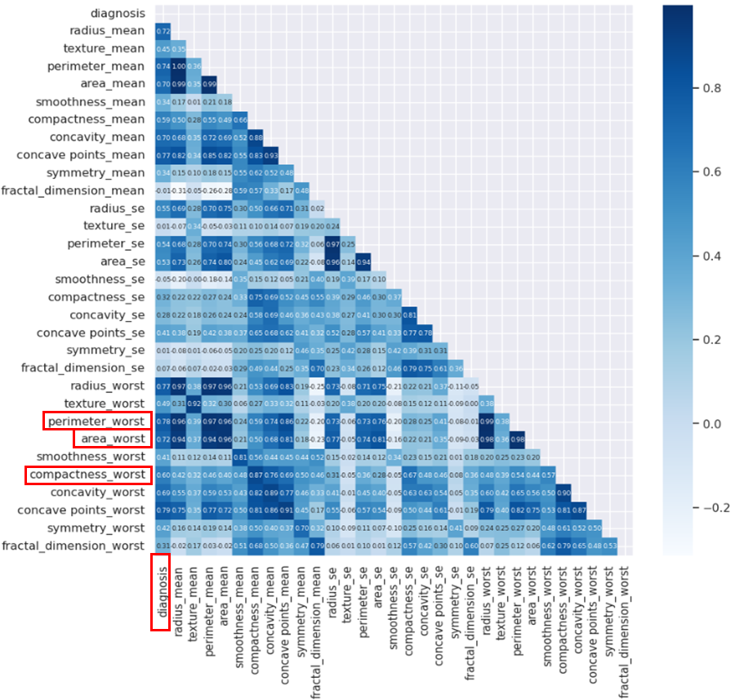dots, thus they alone won't be able to give good accuracy.

**Fig. 5. Heatmap showing correlation coefficients between all attributes in the dataset. The red markers indicate the top 3 prevalent features that show a strong correlation with the label (diagnosis)**

1. Dimensionality Reduction with PCA: We performed PCA on all 30 features to obtain 30 new features with the variance of the distribution of data in the decreasing order shown in Fig. 7. The first point in the output shows the new features in decreasing order of variance, that is, how well they distribute and spread the data. The 2nd, 3rd, and the points further down show the combined variance value of the first 2, first 5, …upto the first 20 features. For example, with just the first 10 features obtained by PCA, we can distinguish approx. 96% of the data! The reason why these new features are better is that the more the data is spread, the easier it is to categorize them into B and M.

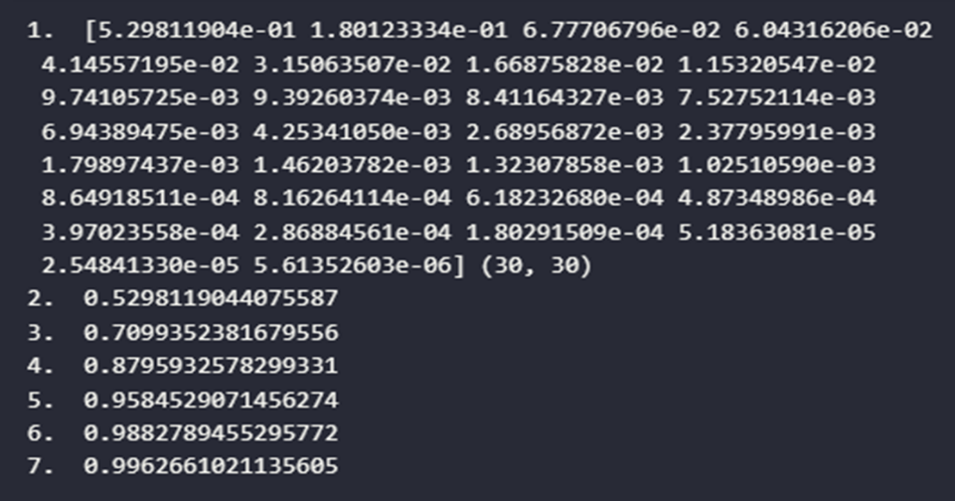**Fig. 6. Scatter plot for top 3 prevalent features obtained from The Heatmap in Fig. 5.**

***Fig. 7. Variance of new features obtained by performing PCA.***

**1. Variance values for the new 30 features in decreasing order**

**2. The first feature itself has a variance value of approx. 53%**

**3. The first 2 features combined have a variance value of approx. 71%**

**4. The first 5 features combined have a variance value of approx. 88%**

**5. The first 10 features combined have a variance value of approx. 96%**

**6. The first 15 features combined have a variance value of approx. 99%**

***7. The first 20 features combined have a variance value of approx. 99.6%***

1. Evaluating Performances of the ML Models for Original 30 Features: We ran ML classifier models with the original features and Fig. 8 is a joint bar graph of the performance evaluations of each model. According to the graph, the accuracy of the DT and RF models of the training set is 1, but the corresponding test set has a significantly lower accuracy. This means that the model is overfitting on the training set and not learning general patterns.

The other models show an expected pattern where they have a test accuracy slightly lower than the training accuracy. This shows that they are not overfitting. Of all the models, SVM has the highest test accuracy.

**Fig. 8. Evaluating Performances of the ML Models for Original 30 Features**

The precision of DT and RF models of the training set is 1, but the corresponding test set has a significantly lower precision. This means that these test set models have a higher number of false positives. The other models, in contrast, have a slightly lower precision score for the training set. This show that they have a few false positives.

For the test set, LR, SVM, and KNN have a precision of 1. This means that there are no false positives. The model that has the best combination of precision scores is SVM. The recall score of SVM for the testing set is the highest among other models. This means that the model has fewer false negatives. On the other hand, the recall score for all other test set models is low, which means that there are quite a few false negatives. Overall, DT and RF had the lowest performance, and SVM had the best overall model performance.

1. Evaluating ML Models with Test Set Recall Scores for Features Obtained after PCA: We used the same ML models again with the new features that were obtained after PCA. We ran all the models for the first 5, 10, 15, 20, and all 30 features. We then plotted a line graph that shows the test set model performances based on the Recall score (Fig. 9). The X axis on the plot shows the number of new features used to train and test the model, and the Y axis consists of the recall scores.

According to the plot, the models' performances do not improve as we increase the number of features from 5 to 30. (Except KNN which stops increasing after 15). This means that just the top 5 (15 for KNN) PCA features are needed to achieve the best possible performance.

**Fig. 9. Recall score for different ML models with PCA features of the test set.**

However, the best model under PCA still doesn't perform as well as the best model with the 30 original features, that is, the test set SVM model with a recall score of 92.3%). Except for logistic regression, all have the same recall score. This shows that the PCA features themselves are not that great compared to the original features. In this case, again, DT and RF performed poorly as shown in the figure. This means that both models are overfitting on the train data instead of following a general pattern.

**Discussion**:

For sensitive classifications, such as B and M in this case, we cannot afford to classify Malignant as Benign. Thus, in such a situation, the recall score is the most important. DT and RF models were highly overfitting on the training data. This is why they had poor model performance. The best model under PCA still doesn't perform as well as the best model with the 30 original features. This shows that PCA features themselves are not that great. Of all the models SVM had the best model performance with high test set accuracy, precision, and recall scores. This means that SVM is the best model for the classification of BC, however, its recall score was just 92.3%. This score can be increased by possibly increasing the amount of training data, or by implementing more complex models such as Artificial Neural Networks.

**References**:

Figueroa, J. D., Gierach, G. L., Duggan, M. A., Fan, S., Pfeiffer, R. M., Wang, Y., … Rohan, T. E. (2021). *Risk factors for breast cancer development by tumor characteristics among women with benign breast disease*. Breast Cancer Research, 23(1). doi:10.1186/s13058-021-01410-1

Antmen, E., Demirci, U., & Hasirci, V. (2019). *Amplification of Nuclear Deformation of Breast Cancer Cells by Seeding on Micropatterned Surfaces to Better Distinguish Their Malignancies.* Colloids and Surfaces B: Biointerfaces, 110402. doi:10.1016/j.colsurfb.2019.11040210.1016/j.colsurfb.2019.110402